*By Devadharshini.M*

*Rajalakshmi Institute of technology.*

1.INTRODUCTION

KNIME (Konstanz Information Miner) is an open-source data analytics platform designed for data integration, processing, analysis, and visualization. KNIME is widely used in industries such as finance, healthcare, and marketing for its flexibility, ease of use, and strong community support, making it a powerful tool for data scientists and analysts. This analysis is about **WORLD HAPPINESS** report using LLM nodes.

**2.**LIST OF NODES

* GPT4ALL Embedding Connector Node
* CSV Reader Node
* Number to String Node
* Chroma Vector Store Creator Node
* Table Creator Node
* Vector Store Retriver Node
* Ungroup Node
* The Title view (Java Script) Node

3. ABOUT THE NODES

1.GPT4All Embedding Connector

Connect to an embeddings model that runs on the local machine via GPT4All. The default model was trained on sentences and short paragraphs of English text.

2.CSV Reader

Reads CSV files. To auto-guess the structure of the file click the Autodetect format button. If you encounter problems with incorrect guessed data types disable the Limit data rows scanned option in the Advanced Settings tab. If the input file structure changes between different invocations, enable the Support changing file schemas option in the Advanced Settings tab. For further details see the KNIME File Handling Guide [*File Handling Guide*](https://docs.knime.com/latest/analytics_platform_file_handling_guide/index.html).

3.Number to String Node

Converts numbers in a column (or a set of columns) to strings. Note that for an advanced configuration, such as rounding or representation in scientific notification you can also use the "Round Double" node.

  4.Chroma Vector Store Creater

The node generates a Chroma vector store that uses the given embeddings model to map documents to a numerical vector that captures the semantic meaning of the document.

By default, the node embeds the selected documents using the embeddings model but it is also possible to create the vector store from existing embeddings by specifying the corresponding embeddings column in the node dialog.

5.Table Creator Node

Allows the manual creation of a data table. The data can entered in a spreadsheet like table

6.Vector Store Retriever Node

A vector store retriever is a component or module that specializes in retrieving vectors from a vector store based on user queries. It works in conjunction with a vector store to facilitate efficient vector retrieval and similarity search operations

7.Ungroup Node

Creates for each list of collection values a list of rows with the values of the collection in one column and all other columns given from the original row. Rows with an empty collection are skipped, as well as rows that contain only missing values in the collection cell with the 'Skip missing values' option enabled.

8.Title view (Java script)

This node provides a tile view where each data row is displayed as one tile. The view offers several interactive features, as well as the possibility to select rows.

The node supports custom CSS styling. You can simply put CSS rules into a single string and set it as a flow variable 'customCSS' in the node configuration dialog. You will find the list of available classes and their description on our [documentation page](https://knime.com/css-styling).

**4.PROCEDURE**

STEP1: Download the CSV File

Download the world happiness report from the given link below:

[https://github.com/PhilippeCodes/World-Happiness-Report-Data-Analysis/blob/master/World Happiness Report.csv](https://github.com/PhilippeCodes/World-Happiness-Report-Data-Analysis/blob/master/World%20Happiness%20Report.csv)

This file contains 13 columns namely( country, happiness rank,happinessscore,economy,family,health,freedom,generosity,corruption,job satisfaction and region) and 154 rows.

**STEP 2: Instal KNIME Extenstion**

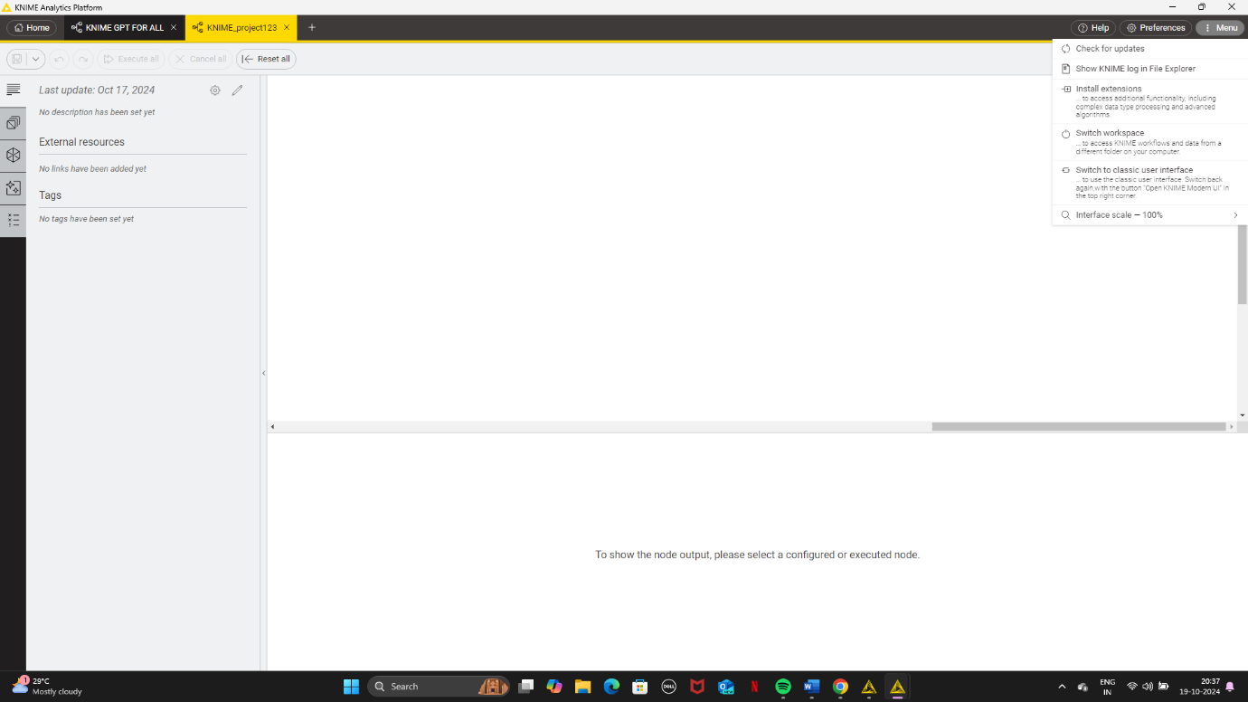

**Go to menu – Instal extension – Choose AI extension -Apply -Ok**

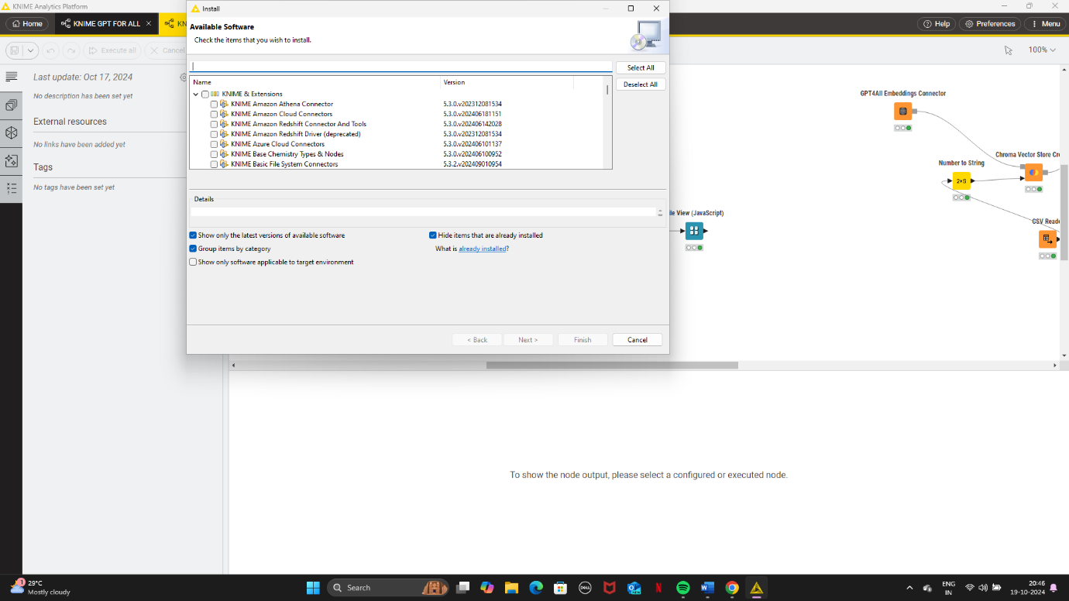

**STEP 3: GPT4 All Embedding Connector Node**

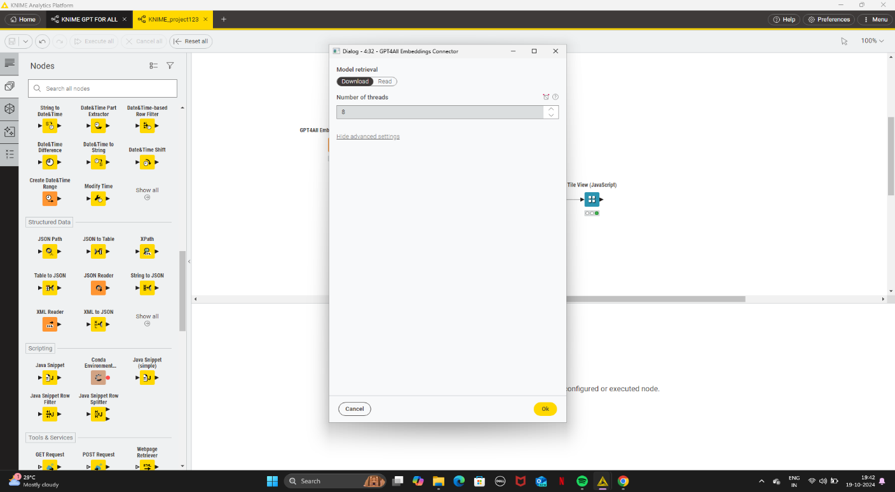 **Connect to an embeddings model that runs on the local machine via GPT4All. The default model was trained on sentences and short paragraphs of English text.**

**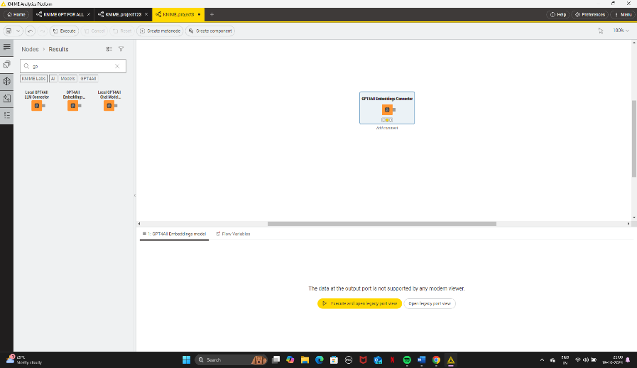  
 Drag and Drop the GPT4All node on Work flow – right click -configurate-no of threads=8( high number of threads would be better) – right click -execute**

**STEP 4: Drag and drop the downloaded csv file from downloads folder from file explorer -right click -configurate-right click -execute**

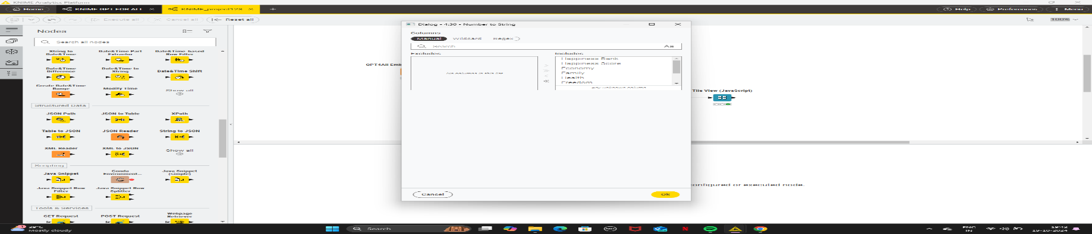 **STEP 5: Drang and Drop the Number to String node- right click-configurate-Execute-**

**Connect the output of CSV reader Node to the input of Number to string node.**

**STEP 6:**

**Dragg and drop thr Chroma vector store create Node from node repository- right click-configurate and in documentation coloumn choose country-in meta data include all the colunms except country column**

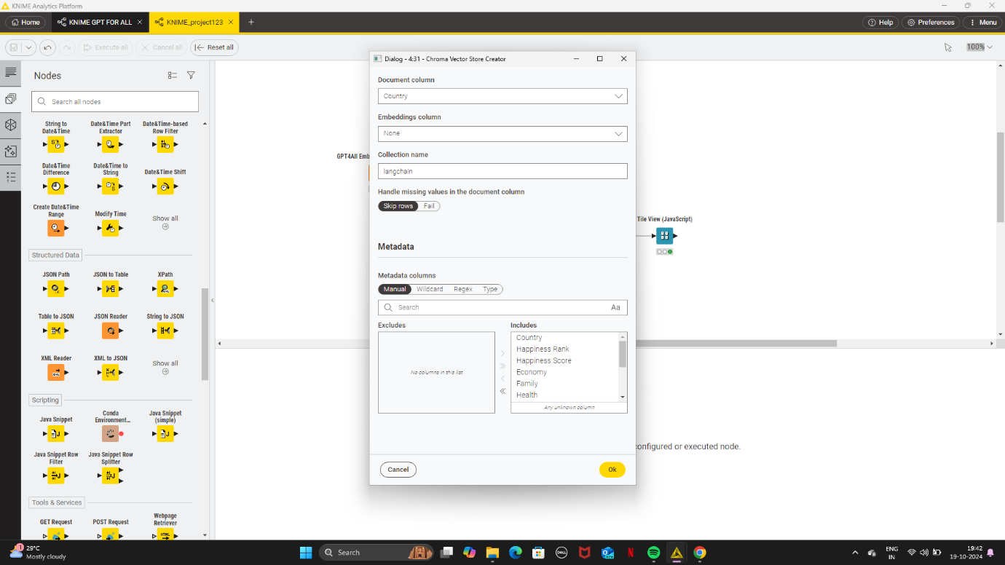

* Connect the output of GPT4All embeddings connector node to the first input of Chroma vector store creater node and connect the output of Number to String node to the 2 nd input of Chroma vector node.

STEP 7:

Dragg and drop the table creator node and configurate and choose a column rename it as question. In the first cell of the column ask the question regarding the CSV File .type it. Example( describe India’s Happiness report)- execute

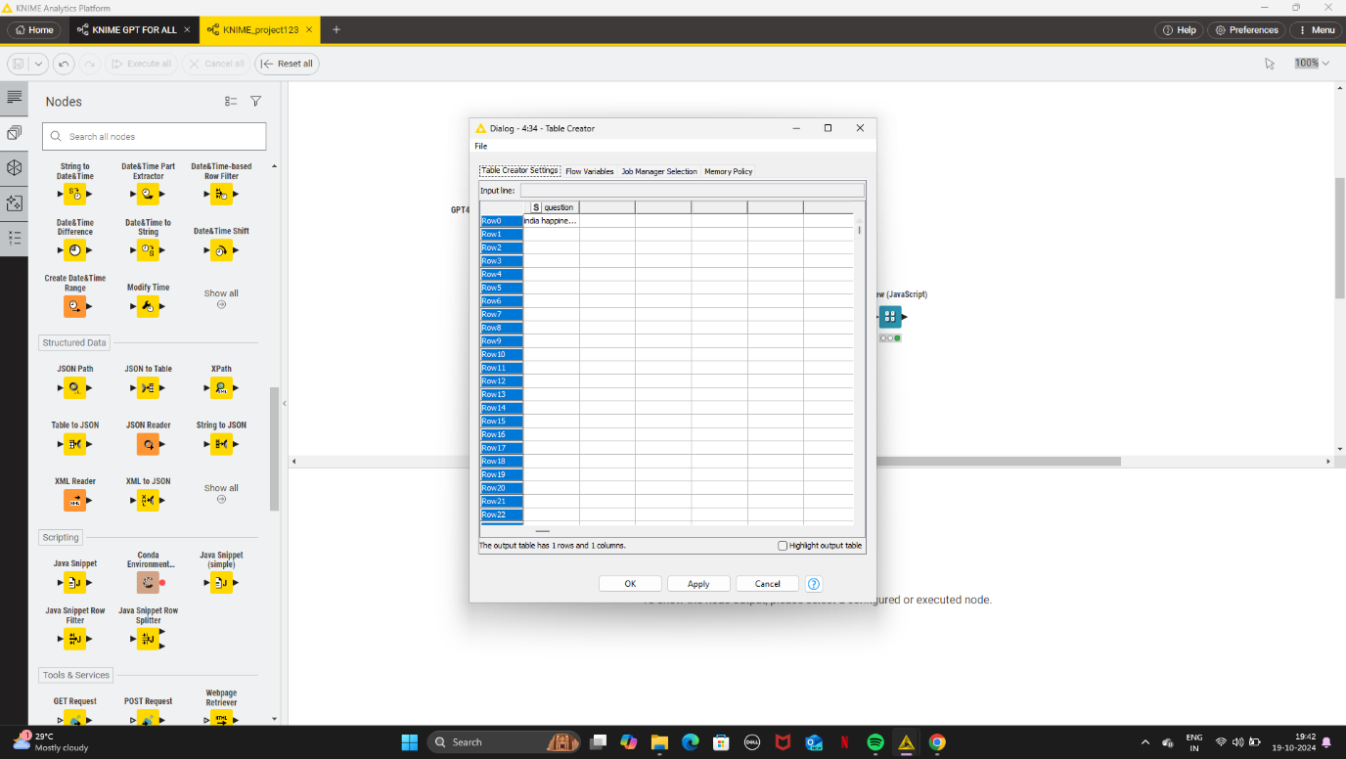

STEP 8:

Dragg and drop the Vector store retriever Node. Connect the output of Chroma vector node to the 1 st input of Vector store retriever node and connect the output of the Table creator node to the 2nd input of Vector retriever node. Right click and configurate and In queries selection question and execute.choose no of results as per the question.

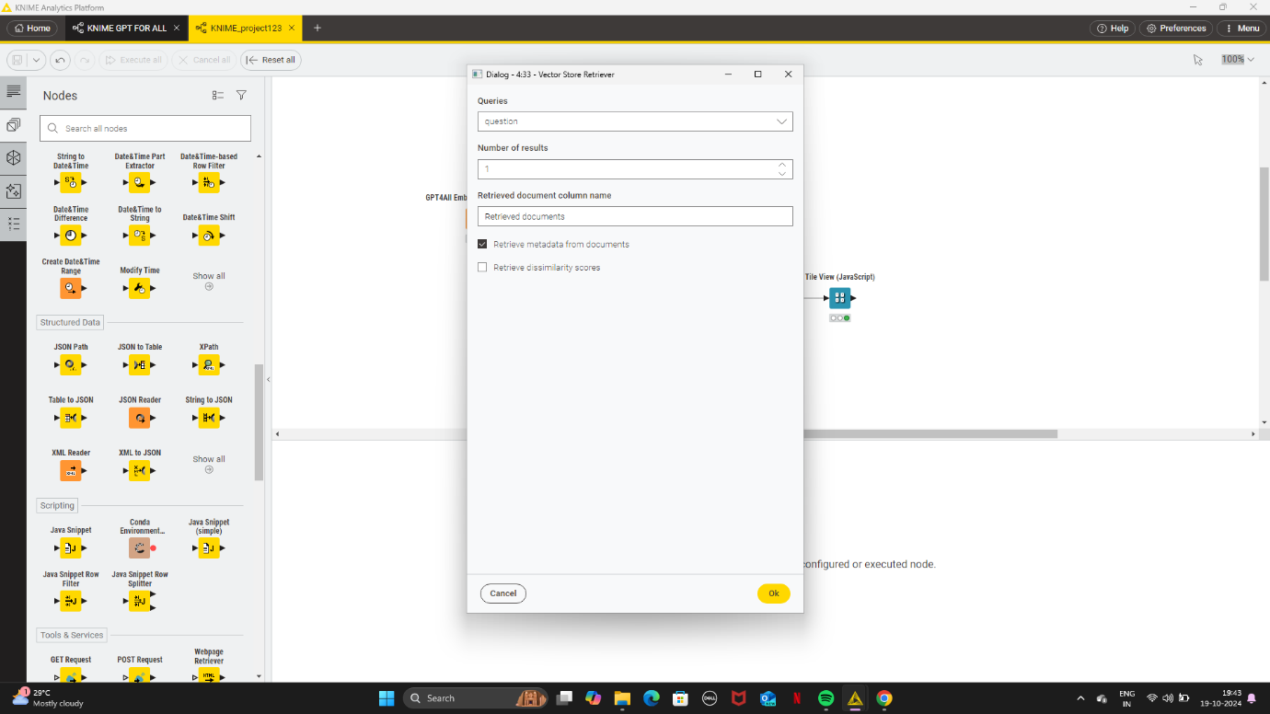

STEP 9:

Dragg and drop the Ungroup node . connect the output of Retriever node to the input of Ungroup node. Configurate and Execute .

STEP 10 :

Dragg and drop the Title viewer (Java Script) node and connect the output of Ungroup node to Title view node.Configurate and execute and open view .click the finder icon to see the title view. 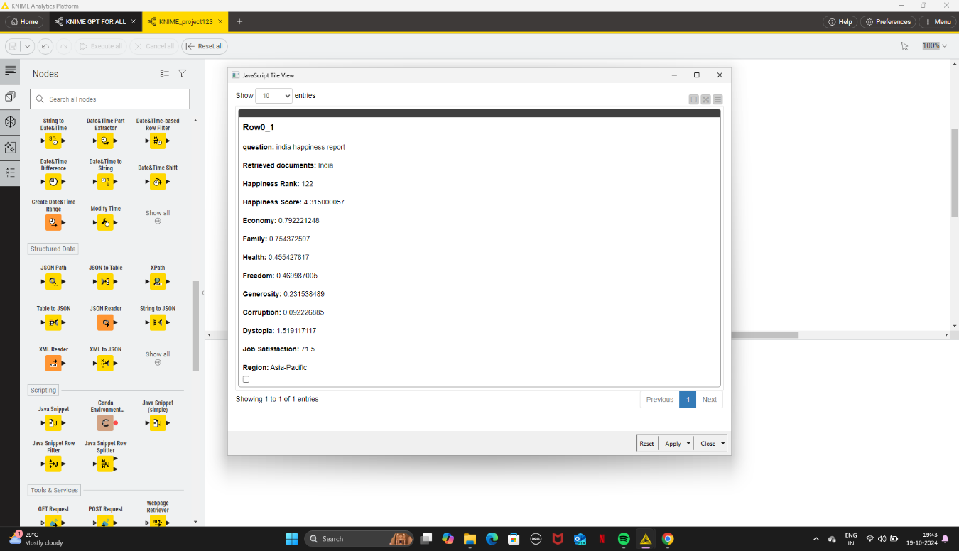

4.CONCLUSION :

Finally . This is the workflow:

